SPINACH


C Level Specification
for
Interpreter Front End

Version 1.0
9th November, 2009

CSE 784 – Software Studio

Kuldeep Gandhi
Deepak Goyal
Srinivasan Sundararajan
Vinit Mehta

Vinit:
- BODMAS
- Function definition
- Function call
- Equality and non equality operations.

Kuldeep:

- Class Element:

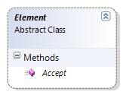

- Class Return Element:

Syntax: return a;
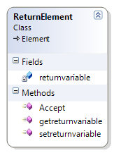

Return element would just set the return variable. It can be included in any loops or any function definition.

- Class MatrixTranspose

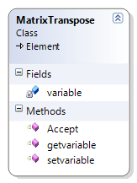

Syntax: Ta where is a is a matrix element.

- Class AdditiveElement

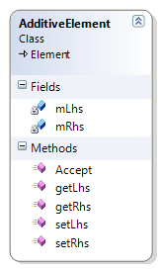
CLASS NAME – AdditiveElement
This class supports addition operation statements. It inherits from the Element class and would support a statement of the following type.

Example: A + b*(a-c)

So, additiveElement would have :
Lhs = A;
Rhs = b*(a-c);

The additive operations can only have multiplication , bracket or any other addition element on its lhs or rhs.

.

- Class MatrixReference:

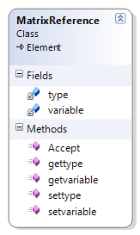

CLASS NAME – Matrixreference Element
This class supports passing matrix elements as function arguments in function statements. It inherits from the Element class and would support a statement of the following type.

Example: Matrix<int> a;

So, Matrix reference Element would have :
Type: int;
Variable: a;

- SubtractionElement:

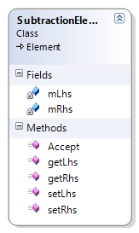

CLASS NAME – SubtractionElement
This class supports subtraction operation statements. It inherits from the Element class and would support a statement of the following type.

Example: A - b*(a+c)

So, subtraction Element would have :
Lhs = A;
Rhs = b*(a+c);

The subtraction operations can have all other BODMAS operations element on its lhs or rhs.

- BracketElement:

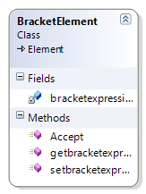

CLASS NAME –Bracket Element
This class supports Bodmas Bracket statements. It inherits from the Element class and would support a statement of the following type.

Example: (A+B-C*D)

So, Bracket Element would have:
It would the entire bracket expression as (A+B-C*D)

The , Bracket Element operations can have only all operations element in the expression.

- Class MultiplicationElement:

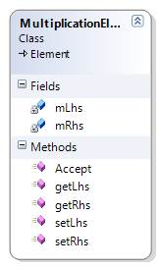

CLASS NAME – MultiplicationElement
This class supports multiplication operation statements. It inherits from the Element class and would support a statement of the following type.

Example: (a+b-c) *d

So, subtraction Element would have :
Lhs = (a+b-c);
Rhs = d;

The multiplication operations can have only bracket element or other multiplication element operations element on its lhs or rhs.

- Class FunctionCallElement:

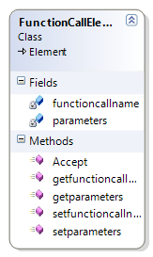
CLASS NAME – functioncallElement
This class supports function call statements. It inherits from the Element class and would support a statement of the following type.

Example: calculate(a, b);

So, function call Element would have :
Functioncallname : calculate;
List of Parameters: {a,b};

The function call can take in all types of arguments as matrix , vector , scalar variables and string.

- Class CommentElement:

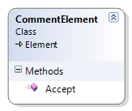

- Class FunctionElement:
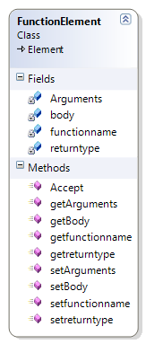

CLASS NAME – functioncallElement
This class supports function definition statements. It inherits from the Element class and would support a statement of the following type.

Example: int calculatesum (matrix<int> a , double b , vector<double> c)
{
//For statement;
//bodmas operations;
}

So, function definition Element would have :
Return type: int;
Functioncallname: calculatesum;
List of arguments: {matrix, scalar , vector};
List of Body:{for , bodmas};

The function call can take in all types of arguments as matrix , vector , scalar variables and string.
The function body can have an other spinach code other than another function definition element.

- Class VectorReference:

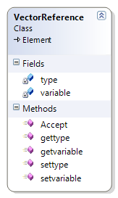
CLASS NAME – Vectorreference Element
This class supports passing vector elements as function arguments in function statements. It inherits from the Element class and would support a statement of the following type.

Example: Vector<int> a;

So, vector reference Element would have :
Type: int;
Variable: a;

- Class DotProductElement:

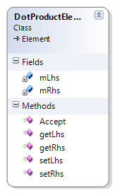

This class supports DotProduct operation statements. It inherits from the Element class and would support a statement of the following type.

Example: cDOTd

So, subtraction Element would have:
Lhs = c;
Rhs = d;

The dot product operations can have only vector element on its lhs or rhs.

- Class exec

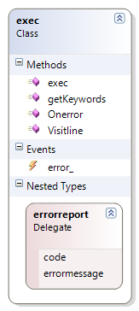

- Class Program:

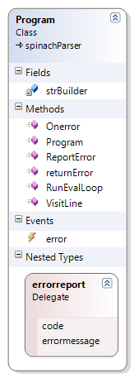

- Class Keywords:

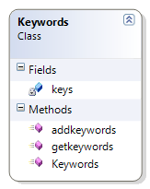

///-- issues:

- string
- comment;

///-- completion table.

TEAM’s STATUS:

TASK | STATUS
Creation of variables | Completed
Creation of structure | Completed
Deletion of variables | Completed
Error to output | Completed
String Input | Completed with Issues
Non recursive functions | Completed
Matrix Operations | Completed with Issues
Comments | Completed with Issues
Testing Equality and Nonequality | Completed
If statements | Completed
For statements | Completed
Parallelfor Statements | Completed
Parallelfor synchronization | Completed
Plot functions | Completed

